**National University of Computer & Emerging Sciences, Karachi**

**Artificial Intelligence-School of Computing**

**Fall 2023, Lab Manual - 02**

|  |  |
| --- | --- |
| **Course Code (AI4002)** | **Course: Computer Vision Lab** |
| **Instructor(s):** | **Sohail Ahmed** |
| **Student Name:** | **Manahil Fatima Anwar** |
| **Roll Number:** | **20K-0134** |
| **Section:** | **BAI-7A** |

1. **Lab Tasks**
2. **Exploring Datasets and their Attributes**

Question: You have a dataset containing images of pets categorized into four classes: Angry, Sad, Happy, and Others. Explore the dataset to understand its attributes. Display the number of samples in each class.

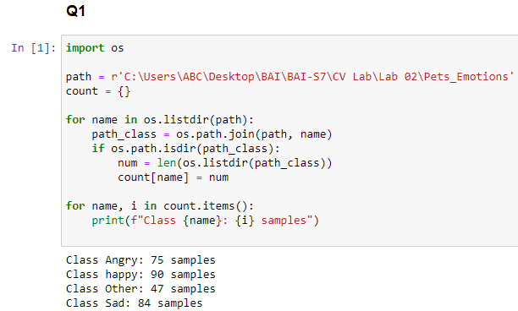

1. **Loading and Preprocessing Dataset**

**Scenario**: Load the pet emotions dataset, resize the images to a common size (e.g., 224x224), normalize the pixel values, and split the dataset into training and testing sets.

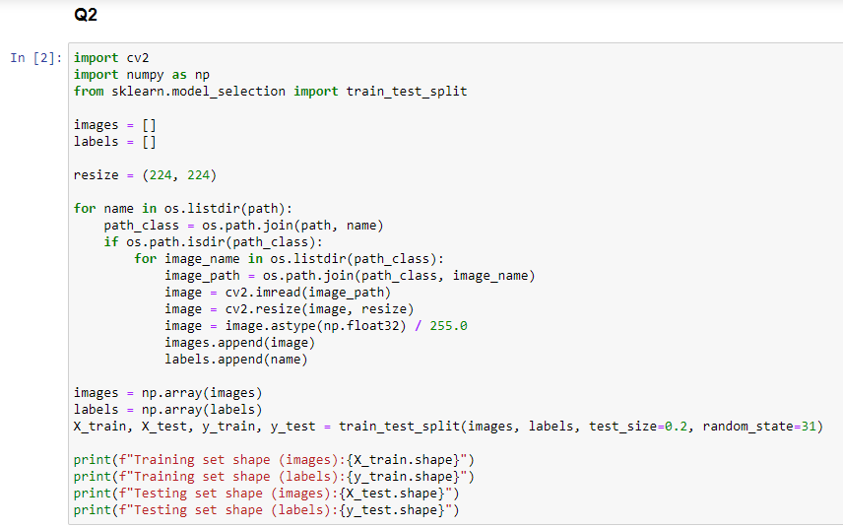

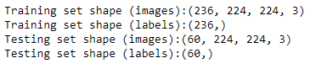

1. **Exploratory Data Analysis (EDA)**

**Scenario**: Perform EDA on the pet emotions dataset. Display the distribution of class labels using a bar plot.

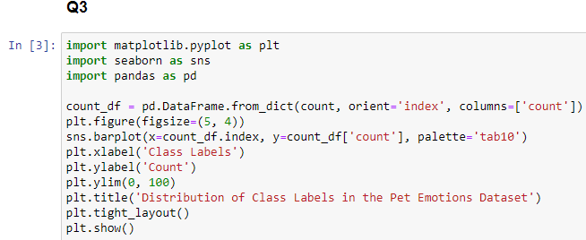

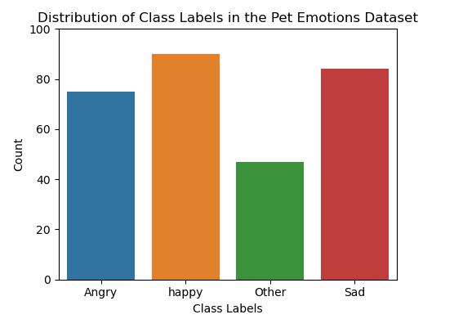

1. **Data Visualization**

Scenario: Display a few sample images from each class of the pet emotions dataset along with their labels.

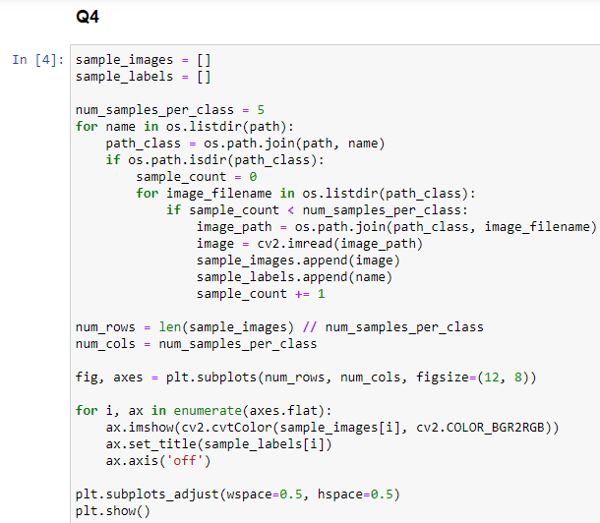

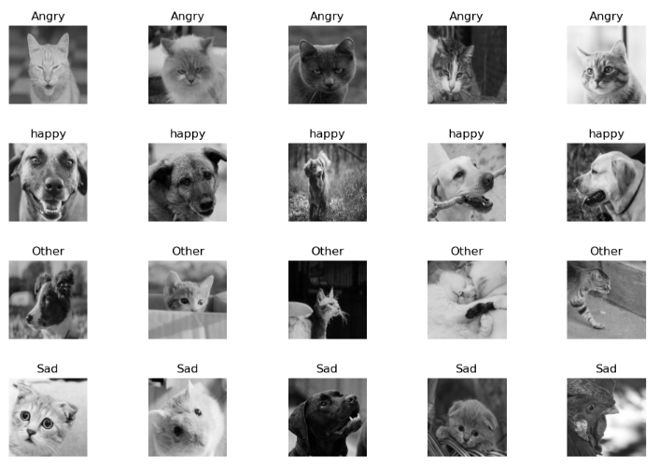

1. **Summary Statistics**

**Scenario**: You want to understand the distribution of emotions in the dataset. Calculate summary statistics for each class (Angry, Sad, Happy, Others).

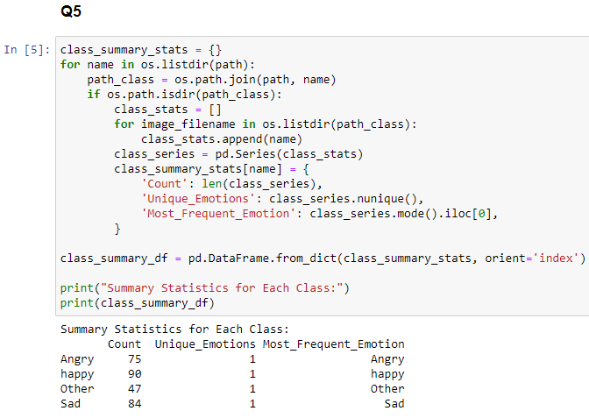

1. **CVPR 2022**

**Task:** Take any two datasets of your own choice, explore the stat of art datasets, their attributes and the code in which the datasets have been used. Take the papers along with those datasets of your choices and decode the papers as much as possible. (Link to CVPR 2022 Datasets: <https://cvpr2022.thecvf.com/dataset-contributions>) Submit this task within two weeks.

Will submit it via email before the deadline.